G. Collective Action and   
Siemens Integrity Initiative

The Legal and Compliance Collective Action & External Affairs Team (LC CO RFC CA, Collective Action Team) coordinates the Collective Action activities at Siemens. Collective Action was started in 2008 and is an activity field of the Siemens Compliance System and described in the [Siemens Circular 226](https://regulations.siemens.com/content/sc/226/en), Chapter 3 “Prevent”, Article 12 “Collective Action” as well as in the [Compliance Operating Model](https://regulations-admin.siemens.com/content/sst/4/en) Chapter 2.2 “Prevent” and its Appendix “Summary of mandatory items”.

Collective Action, which involves building alliances against corruption in order to level the playing field, is an integral part of the Siemens Compliance System and one of the priority focus topics.

|  |
| --- |
| All Siemens units planning Collective Action activities:   * should involve their respective Compliance Officer and the Compliance Collective Action team. * must follow the [Antitrust Guidance](https://lkb.siemens.com/content/00000008/LegalKnowledgeBase/y5t2v021dbqp/LKB000764.pdf) for Collective Action ([Compliance Handbook, G.3.](https://webbooks.siemens.com/public/LC/chen/index.htm?n=Part-1-Activity-Fields,G.-Collective-Action,G.-Collective-Action-and-Siemens-Integrity-Initiative,3.-Guidance-on-Antitrust-in-Collective-Action)). |

Siemens actively drives the implementation of Collective Action and aims to set up projects with partners in industry, the public sector, non-governmental organizations, international organizations and civil society.

In addition, Siemens has started the Siemens Integrity Initiative with a budget of more than US$ 100m as part of the settlement agreed with the World Bank in July 2009 and the European Investment Bank (EIB) in March 2013. The initiative funds organizations, projects and training activities worldwide in the fight against corruption.

More information can be found at: [www.siemens.com/collective-action](http://www.siemens.com/collective-action) and [www.siemens.com/integrity-initiative](http://www.siemens.com/integrity-initiative).

## 1. Collective Action in a nutshell

Over recent years, Siemens has successfully introduced and implemented a comprehensive global Collective Action program and the Siemens Integrity Initiative to jointly fight corruption and promote integrity in business transactions.

The ultimate goal is to establish fair and sustainable market conditions in collaboration with other companies, governments and non-governmental organizations for the benefit of all market participants.

* Corruption is theft from a country and its citizens. It cripples democratic and economic development and distorts fair competition.
* Money flowing into dark channels is absorbed and is therefore unavailable for investments in infrastructure. This limits the prosperity of an economy.
* Experience has shown that, without an adequate anticorruption culture based on Long-Term Initiatives, Integrity Pacts and Compliance Pacts are difficult to implement or do not result in sustainable change.
* We have therefore concentrated our focus on further expanding Long-Term Initiatives, which are also supported by the Siemens Integrity Initiative.
* We are continuously driving our strategy: from fighting corruption to market development through business-minded Collective Action activities

**The benefits:** Lower levels of corruption help to develop markets and reduce risks.   
More public spending will be available; financial and socio-economic stability is fostered; investors are attracted; civil society is encouraged; peace and security dialog is supported.

**The result:** Increased market volumes with higher addressable market shares for suppliers based on fair competition, which ultimately drives innovation and prosperity for all stakeholders.

Collective Action enables corruption to be fought collectively, with various interest groups working together and building an alliance against corruption so that the problem can be approached and resolved from multiple angles. It calls for cooperation on the part of participants from the worlds of politics, business and society at large.

The ultimate goal of Collective Action is to create fair and equitable market conditions and thus establish a “level playing field” for all marketplace participants, eliminating the temptation of corruption for all those concerned.

Collective Action is therefore part of the Siemens Compliance Priority “Foster Integrity”.

All in all, Collective Action and the Siemens Integrity Initiative are a key element to ensure clean business and to mitigate risk.

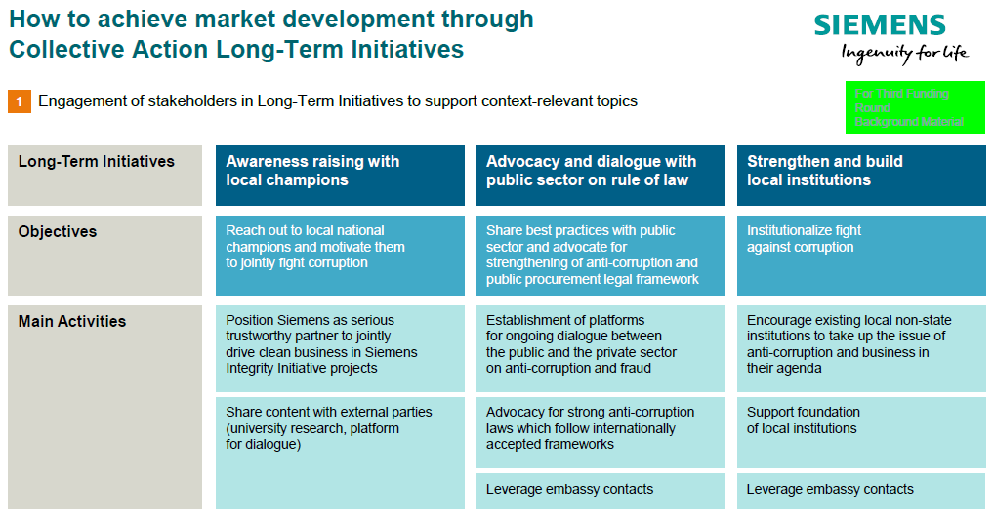

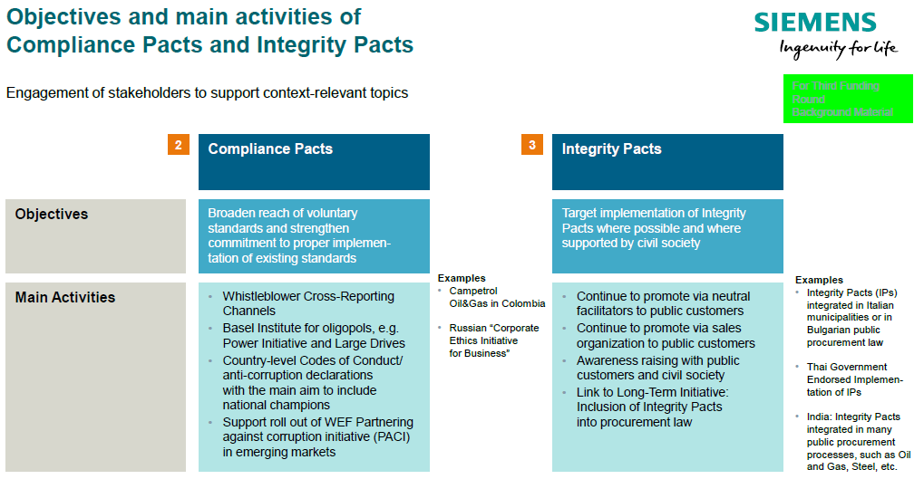

## 2. How to create a level playing field through Collective Action

In the face of the widespread and deep-rooted corruption problem that affects society in general, governments and their procuring entities and the private sector in equal measure, it seems highly unlikely that individual activities alone will be sufficient to bring about significant ethical changes and improve the transparency of business processes.

**This is precisely where Collective Action methods come into their own.**

### 2.1. Starting point and background

Collective Action methods make it possible for us to fight corruption collectively, working together with the various interest groups to build an alliance against corruption and to approach and resolve the problem from multiple angles. The ultimate aim of these joint efforts is to create fair and equal market conditions – a "level playing field" – for all market players and eliminate the temptations of corruption for all.

Collective Action promotes a fair competitive situation in which a transparent process based exclusively on market economic criteria (such as quality, price, innovation and service) ensures that the contract is awarded to the best bidder. It prevents competition from being distorted and destroyed by corruption and ensures that companies acting honestly and morally are not disadvantaged.

The success of the initiative hinges to a great extent on the trust and commitment of the parties at the highest management level, as well as a general consensus regarding the consequences and sanctions to be applied if the agreed processes and rules are breached. It is important for each participant to demonstrate the credibility of its intentions by implementing its own compliance program to a recognized standard.

The available methods range from Integrity Pacts for individual procurement transactions right through to industry-specific Codes of Conduct and Compliance Pacts, as well as joint measures implemented as part of a long-term initiative to raise a country's public awareness and tighten up its regulatory system and procurement guidelines. Ideally, such action should involve competitors, authorities, non-governmental organizations (NGOs) and other interest groups working jointly for the common good. It is also crucial to examine the antitrust aspects in each individual case.

Siemens is engaged in a variety of cooperative projects with NGOs (non-governmental organizations) and IOs (international organizations) committed to fighting corruption and establishing and maintaining freedom of competition. We have, for example, been very actively involved in the Collective Action working group of the World Bank Institute. We are also a permanent member of the working group for the tenth principle (anti-corruption) of the UN Global Compact and of the Commission on Anti-Corruption of the International Chamber of Commerce (ICC), as well as a long-standing Sherpa in the G20/20 process since 2011.

Through our cooperation with NGOs and IOs such as the World Bank, we are continuously working to improve our established Compliance Program in dialogue with our partners and assume a leading role in the field of compliance and transparency.

With the clear objective of becoming a respected international partner in the fight against corruption, we are striving to extend this commitment even further in the future.

### 2.2. “The House of Collective Action”

As described in the previous chapter**,** Collective Action enables corruption to be fought collectively, with various interest groups working together and building an alliance against corruption so that the problem can be approached and resolved from multiple angles.

The advantages of Collective Action:

* Collective Action combines various methods of combating corruption. It involves acting collectively and forming alliances against corruption.
* Collective Action calls for cooperation on the part of participants from the worlds of politics, business and society at large.
* Its ultimate goal is to create fair and equitable market conditions and thus establish a “level playing field” for **all** marketplace participants, eliminating the temptation of corruption for all those concerned.
* Collective Action helps to set up the conditions for fair competition within a corrupt environment.
* Collective Action promotes innovation, as bidders are selected solely on the basis of their price, quality and capacity to innovate.
* Observance of antitrust law when collaborating with other companies must be ensured by a neutral monitor (for example in the form of a non-governmental organization).
* Collective Action can, if necessary, cover gaps in legislation or replace or augment inadequate local law.

At Siemens, the Collective Action methods encompass project-specific, sector-wide and long-term initiatives.   
All activities, global and local, are driven through complementary channels.

This is partly illustrated in the “House of Collective Action” and its individual parts are described below:

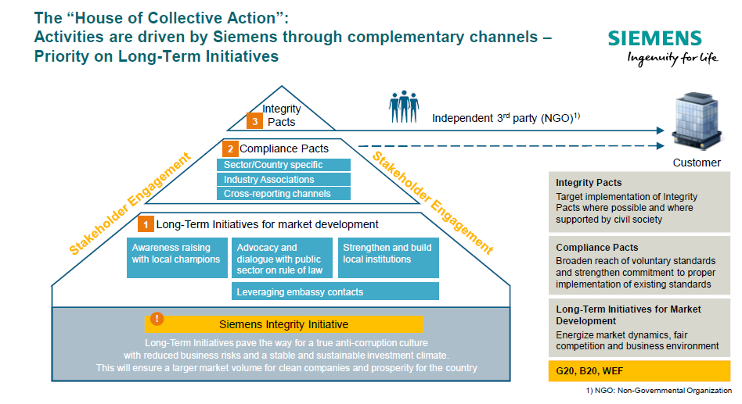

#### 2.2.1. Project-specific methods – Integrity Pacts

Integrity Pacts help to ensure that the procedure for awarding orders in public-sector contracts is free from corruption.

These methods were developed by the non-governmental organization “Transparency International”. They are intended to guarantee transparency in the order-awarding process and to rule out bribery in the awarding of public-sector contracts.

Following an invitation to tender from a public-sector customer, the bidding companies sign legally binding contracts, and commit themselves to behaving with integrity from the start of the tender process until the end of the project. If the contract is breached, sanctions are imposed, which can be as severe as the exclusion of the company from further invitations to tender.

An independent monitor supervises the contract-awarding process and observance of the Integrity Pact.

Integrity Pacts help to ensure that bidders are selected on the basis of fair criteria and serve all the stakeholders as a means of protecting the integrity of the project.

Please refer to Integrity Pact Templates at the [Collective Action Download Center](https://intranet.for.siemens.com/cms/059/de/processes/publications/Pages/compliance_collective-action-download-center.aspx).  
(Under category Collective Action Legal Center of Competence)  
For support with the templates, please contact Christina Wolfgramm or Ulrike Desimoni (LC CO RFC LF).

#### 2.2.2. Sector-wide codes of conduct / Compliance Pacts

Companies from the same sector get together and draw up a code of ethics or code of conduct.

These can take various forms, ranging from principles-based provisions to legally binding agreements. In the latter case, companies that violate the anticorruption code are penalized with sanctions.

However the principles-based codes also have a high degree of effectiveness, as especially the public commitment to anticorruption and transparency exerts increased pressure on the participating companies not to breach the agreement. This type of Collective Action is particularly suitable in oligopolistic markets.

The uncompromising support of senior management within the companies concerned is critical to the success of the initiative. In order to avoid breaches of antitrust law, it is vital to enlist the services of an external, independent monitor.

Please refer to Integrity Pact Templates here in our [Collective Action Download Center](https://intranet.for.siemens.com/cms/059/de/processes/publications/Pages/compliance_collective-action-download-center.aspx).   
(Under category Collective Action Legal Center of Competence)  
For support with the templates, please contact Christina Wolfgramm or Ulrike Desimoni (LC CO RFC LF).

Please also refer to the [Collective Action Antitrust Guidance](https://lkb.siemens.com/content/00000008/LegalKnowledgeBase/y5t2v021dbqp/LKB000764.pdf). For more information, please contact the [Legal and Compliance Competition Team.](https://intranet.for.siemens.com/cms/059/en/about/org/Pages/legal_cmp.aspx)

#### 2.2.3. Long-Term Initiatives for market development

Long-Term Initiatives are particularly effective in states rated as being prone to corruption, as they are essential to pave the way to the establishment of a true anti-corruption culture. Collaboration between government, commercial companies and society in the fight against corruption helps to raise awareness among politicians and the general public.

The acknowledgment that bribery and corrupt behavior damage the entire economy of a state brings long-term benefits for all stakeholders. Long-Term Initiatives set out the fundamental conditions that will enable project-specific Integrity Pacts and industry-specific Compliance Pacts to come to fruition and achieve general acceptance.

Their success contributes to a world free from corruption and helps to direct the investment of many millions of euros and other resources toward their intended destination. In addition, and as an important element of our Long Term Initiatives, Siemens is deeply engaged in the B20 Task Forces on Improving Transparency and Anti-Corruption. Since 2011 we have been able to present our positions in the global consultation process at the G20/B20 summits in France, Mexico, Russia, Australia, Turkey, China, Germany, Argentina, Japan, and currently in Saudi Arabia.

As described in the background, our many engagements in e.g. the New York-based United Nations Global Compact (10th Principle), our work with the Commission on Corporate Responsibility and Anti-corruption of the International Chamber of Commerce in Paris, our representation of Siemens in the World Economic Forum’s Pact Against Corruption Initiative (PACI) in Switzerland, and other C-Level support contribute to our Long-Term Initiatives.

#### 2.2.4 Collective Action Stakeholder Mapping

In April 2011, we started Phase II of the “Collective Action Country Strategy & Stakeholder Mapping Process” and have implemented an ongoing process since then.

Please find our latest Stakeholder Mapping Analysis, dated April 2018 [here](https://findit.compliance.siemens.com/content/10000101/Compliance/LC_CO/LC_CO_CA/findIT_LC_CO_CA_7418.pdf).

Collective Action Stakeholder Mapping

* ensures a thorough analysis of the specific country situation and permits a structured approach to potential anticorruption stakeholders in the individual country
* helps the responsible Compliance Officer to identify suitable Collective Action partners in the Siemens countries
* supports the establishment of strong relations with our Collective Action stakeholders
* fosters a climate of confidence, which in turn facilitates dialog
* enables stakeholders to share their expertise and engage collectively in anticorruption
* will help to enable a better understanding of specific stakeholder expectations and the concerns of various players and helps to develop a strong anticorruption community and network in all Siemens countries.

Knowing your stakeholders is:

* the prerequisite for selecting partners for Collective Action against corruption
* the successful implementation of Long-Term Initiatives and partnerships, the latter of which provide the basis for facilitating Integrity Pacts and Compliance Pacts in your country by strengthening the anti-corruption mindset
* active stakeholder engagement in the longer term (even if you do not engage in successful cooperation with a certain stakeholder now, it is worthwhile to stay in contact and to look for opportunities for Collective Action in the future)
* the development of future Collective Action opportunities and the positioning of Siemens as an anticorruption leader

## 3. Guidance on Antitrust in Collective Action

Over recent years, Siemens has successfully introduced and implemented a comprehensive global Collective Action Program to jointly fight corruption and promote integrity in business transactions. The ultimate goal is to establish fair and sustainable market conditions in collaboration with other companies, governments and non-governmental organizations for the benefit of all market participants. Therefore, Collective Action promotes a level playing field in which a transparent process based exclusively on the attractiveness of companies’ product or service offerings (such as quality, price, innovation and customer service) ensures that the contract is awarded to the best bidder. Collective Action prevents competition from being distorted and destroyed by corruption and ensures that companies acting honestly and morally are not disadvantaged.

As Siemens’ Collective Action activities include collaboration with other (possibly competing) companies, care must be taken to avoid any conflict of such contacts or discussions with antitrust rules.

Within the framework of the Collective Action Program, discussions with other companies on the coordination of anti-corruption initiatives in compliance **with the limits set by LC M&A CMP** below are entirely legitimate.

Accordingly, care must be taken to ensure that when discussing such issues, competitors do not use the opportunity to enter into anticompetitive agreements or give each other insight into confidential information that ought not to be shared.

### 3.1. Key Principle

The key principle is that all Siemens employees who have contact with other (possibly competing) companies in the context of Collective Action activities must bear in mind that antitrust law requires every company to compete autonomously, on its own merits. This is the case regardless of how laudable the purpose of the cooperation is. In other words, the fact that companies work together to root out corruption and other illicit business practices does not mean that antitrust law is applied any less strictly to such cooperation.

### 3.2. Prohibition of agreeing, implementing or enforcing anticompetitive agreements

Contacts or discussions between companies in the context of Collective Action activities must not be used to agree, implement or enforce any kind of anti-competitive agreement, e.g. related to price fixing, market sharing, bid rigging or collusive tendering, agreements on production / capacities / investments, supplier / customer boycotts.

In addition, Collective Action activities must not be used by competitors to jointly agree on terms of trade to be used with customers. For example, it would not be permissible for competitors to agree that they will no longer agree to unlimited liability clauses in their contracts with customers. Similarly, it may raise antitrust issues to agree not to purchase products or services in specified countries (e.g. due to high corruption risks or low human rights standards) or to agree on certain payment terms with the aim of avoiding terms that would enable the concealment of kickback payments (e.g. cash payments, payment by cheque).

Care must also be taken not to agree on minimum standards in relation to certain areas where, in the absence of mandatory regulation, companies would be competing against each other. For example, it is legitimate for companies to agree to all comply with a particular country’s minimum wage legislation. However, it may be problematic to agree on minimum wage standards that exceed mandatory standards.

### 3.3. Prohibition of exchanging competitively relevant information

In addition, competitively relevant information that can enable competitors to coordinate their conduct on the market must not be exchanged, e.g.:

* prices, price components, rebates and other factors influencing price, production, marketing and

other costs;

* supply/customer relationships (names of suppliers/customers);
* market strategy, product launches, R&D projects;
* investments, withdrawal from business areas or
* other competitively relevant business and trade secrets.

### 3.4. Conduct at meetings

When organizing Collective Action activities and meeting representatives of other (possibly competing) companies at Collective Action gatherings, please bear in mind the following key points:

* It is preferable that Collective Action meetings in which competitors are involved are organized by, and carried out under the auspices of, neutral facilitators such as NGOs or international organizations;
* All interested parties should be able to participate freely in the Collective Action activities, both in the deliberations about new Collective Action measures, as well as in the measures finally agreed;
* Any decision to implement a particular measure should be made in an open and transparent process;
* There should be an agenda for any Collective Action meeting, and the discussions should not stray from the agenda without good reason;
* No competitively relevant information should be discussed;
* If problematic issues are discussed, leave the meeting immediately and contact Legal and Compliance;
* You should be particularly careful during the social side of such meetings (meals, hotel bar, etc.).

### 3.5. Direct contact with competitors

In the context of Collective Action, there may be occasions when Siemens employees contact employees working for competitors or vice-versa. For example, there may be occasions when employees of competing companies discuss whether a particular tender should be supported by an integrity pact. Alternatively, a company may initiate discussions about entering into a compliance pact for a particular business area or transaction.

In the context of Collective Action, direct contact with competitors is generally acceptable as long as the discussions relate purely to the putting in place of appropriate Collective Action arrangements, and do not lead to either anticompetitive agreements or illegal information exchange.

However, the basic rule remains that Siemens employees must not speak to competitors unless they have a compelling business reason to do so and that they can be sure that no antitrust issues arise. As the dividing line between appropriate and inappropriate actions is particularly fine when direct contacts between Siemens and its competitors occur, Siemens employees are encouraged to contact the experts at LC M&A CMP if they have any questions about antitrust rules as they relate to Collective Action.

Further information can be found on our Legal Competition (LC M&A CMP) website:

<https://intranet.for.siemens.com/cms/059/en/about/org/Pages/legal_cmp.aspx> and <https://lkb.siemens.com/content/00000008/LegalKnowledgeBase/y5t2v021dbqp/LKB000764.pdf>

## 4. Siemens Integrity Initiative

Since 2009, LC CO RFC CA has conceptualized and headed the Siemens Integrity Initiative, which is based on Siemens’ agreements with the World Bank dated July 2, 2009 and the European Investment Bank, dated   
March 15, 2013.

With total funding of more than US$ 100 million, the initiative supports organizations and projects that fight corruption and fraud through Collective Action, education and training.

The initial First Funding Round, which disbursed a sum of around US$ 40 million, was launched in December 2009, with projects being announced beginning in December 2010. Under the Second Funding Round, which started in 2013, selected projects are to receive approximately US$ 35,554 million of funding over a period of three to five years.

The Third Funding Round was launched on March 13, 2018 (see [Press Release](https://www.siemens.com/content/dam/internet/siemens-com/global/company/sustainability/compliance/collective-action/pdf/pr2018030198coen-siemens-integrity-initiative.pdf)) and offered a funding volume of up to US$ 30 million for up to 25 projects.

In order to achieve an overall geographically balanced portfolio of projects in the Third Funding Round, preference was given to projects with activities in the following countries:

Adriatic Region, Angola, Argentina, Brazil, China, Colombia, Egypt, India, Indonesia, Iran, Iraq, Ivory Coast, Kenya, Korea, Libya, Morocco, Mozambique, Myanmar, Nigeria, Pakistan, Russia, Saudi Arabia, Spain, South Africa, Syria, Tunisia, Turkey, United Arab Emirates, Ukraine.

Following the announcement of the application modalities, we received applications for the Third Funding Round from some 140 organizations from more than 50 countries with a requested funding volume of more than USD 280 million.

From this large number, we have [committed funding to 22 projects for a total of USD 25.2 million](https://assets.new.siemens.com/siemens/assets/api/uuid:c869bc77-b909-445f-874e-264e3fa92ad5/version:1583509635/third-funding-round-project-profiles.pdf) for the most innovative and promising project proposals. The projects meet our eligibility and selection criteria as described in our ["Green Booklet"](https://assets.new.siemens.com/siemens/assets/api/uuid:6e52e858-12cc-4b37-8ffe-fe319932d078/version:1571665244/siemens-integrity-initiative-important-information-fundinground-.pdf).

Under the leadership of LC CO RFC CA, a global interdisciplinary team (Compliance, Legal, Tax, Finance, Regional Compliance Officers) has conducted a thorough due diligence of the applications before the final selection. The selection of projects takes into account both the range of topics and the regional distribution of funding.

As part of the Siemens-World Bank settlement agreement, the World Bank has audit rights over the use of funds (US$ 100 million over a period of 15 years beginning in 2009) and veto rights over the selection of projects by Siemens. The agreement between Siemens and the European Investment Bank (€ 13.64 million over five years) gives the EIB the right to reject the projects proposed.

As of March 2020, we have supported 77 projects with a committed funding of USD 98.5 million. Overall, our projects are making good progress, and we report on them publicly every year (see, for example, the [Siemens Integrity Initiative Annual Report 2019](http://www.siemens.com/integrity-initiative/Report2019)).

The projects backed in the first rounds of funding have made a tangible difference locally, in regions and sectors, and we are particularly pleased to see more and more committed and well-connected supporters rallying to the Collective Action banner and joining our common effort to fight corruption.

At the request of the World Bank, all 55 projects of the first two funding rounds have in 2017 undergone an external evaluation by the Universalia Management Group, who conclude that “the overall findings of the Mid-term Review are positive”. Please refer to our [**Siemens Integrity Initiative Annual Report 2017**](http://www.siemens.com/integrity-initiative/Report2017), which includes the summary of the Mid-term Review.

Main observations of the Mid-term Review are:

* The Siemens Integrity Initiative has **positively pushed ahead the agendas** on   
  Collective Action
* Since its establishment in 2009, the Integrity Initiative **has gained the respect of many   
  anti-corruption** **actors** around the world.
* It has **highlighted the role of the private sector** in fighting corruption and fraud and **demonstrates the business case** for investing in Collective Action.
* It has contributed to **strengthening the organizational capacities** of several Integrity Partners.
* It has made some contributions to **fostering the generation and exchange of knowledge** among anti-corruption actors.
* Siemens’ **management approach** made effective use of the company’s global presence and ensured **high levels of accountability**, which allowed the Integrity Initiative to trace every dollar spent.

## 5. Training and supporting material

All material about Collective Action and the Siemens Integrity Initiative can be found here:

* Siemens Collective Action Internet page: [www.siemens.com/collective-action](http://www.siemens.com/collective-action)
* Siemens Integrity Initiative Internet page: [www.siemens.com/integrity-initiative](http://www.siemens.com/integrity-initiative)
* [Collective Action Intranet Page](https://intranet.for.siemens.com/cms/059/en/processes/publications/Pages/compliance_collective-action.aspx)
* [Collective Action Internal Download Center](https://intranet.for.siemens.com/cms/059/en/processes/publications/Pages/compliance_collective-action-download-center.aspx), which also provides templates in the “Legal Center of Competence”.

## 6. History of changes

|  |  |  |
| --- | --- | --- |
| **Date** | **Author** | **Major changes of binding content** |
| January 1, 2019 | Sabine Zindera (LC CO GR CAS) | First release through the Compliance Handbook. |
| August 19, 2019 | Sabine Zindera | Second release in light of organizational changes from Oct 1, 2019 (then: LC CO RFC LF) |
| April 1, 2020 | Sabine Zindera LC CO RFC CA | Third release, which essentially describes the new facts regarding the Third Funding Round of the Siemens Integrity Initiative |
| October 1, 2020 | Sabine Zindera LC CO RFC CA | Fourth release, which includes minor refinements |

## 7. Contact

* Compliance Officer

The Compliance Officer responsible for your unit can be found through the following [link](https://intranet.for.siemens.com/cms/059/en/about/org/Pages/compliance_organization.aspx).

* Corporate Governance Owner

Sabine Zindera (LC CO RFC CA)